Clearing the Cloud
PowerPoint Notes
Time: 50 minutes
The objectives of this PowerPoint presentation are:
- To raise awareness among youth in grades 5 to 7 on vaping products
- To provide information to help youth make an informed decision with regards to vaping products
- To prevent youth from vaping

Slide Number | Objective | Talking Points | Comments/Additional Information
1  Title Slide |  | - Provide a brief introduction.  Examples:  - Today, we are going to talk about vaping.  - You may have heard different things about vaping.  - This lesson will give you information to make an informed decision.
2  Fact Check | - To assess the level of knowledge of students on vaping  - To address the misconceptions about vaping products | Game: Fact Check  How to Play:  Make copies of the “Fact Check” activity sheet (fill-in-the-blank) and ask students to choose the missing word from the list provided. You could divide the class into groups of 4-5 students to work on the activity sheet. | - This activity is designed to introduce the content of the PowerPoint.
3  Vaping Facts | - To increase understanding of vaping products – what they are and how they work | - Smoking (e.g. cigarettes, pipes and cigars) burns tobacco. Vaping devices do not burn, rather they heat the e-juice to make an aerosol.  - Aerosol is also knows as vapour or cloud.  - The e-juice has chemicals and flavourings. Most contain nicotine.  - There are more than 7,000 flavours of e-juice.  - Why are there so many flavours? Answer: To hide the “bad” taste of the chemicals and nicotine.  Did you know …?  - Some vapes can explode and cause fires.  - Optional: Share a story from one of the links. | Stories of interest:  - Vape explodes in Alberta teen’s face: https://www.cbc.ca/news/canada/calgary/alberta-father-calls-for-ban-on-e-cigarettes-1.3423099  - Battery explodes on (WestJet) airplane: https://www.cbc.ca/news/canada/calgary/calgary-westjet-emergency-landing-tsb-report-1.4984057  - Vaping product explodes in pocket: https://globalnews.ca/news/3143384/spare-e-cigarette-battery-explodes-in-mans-pocket-in-dramatic-video/
4  Vaping Products  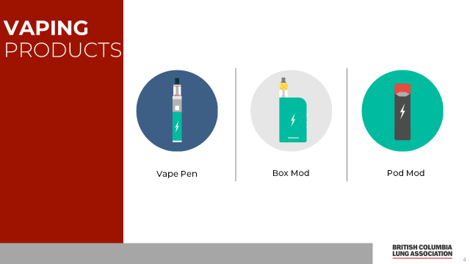 | - To explain the different types of vaping products | - You may hear different names for them, but they work the same way.  Examples: Vape pens, box mods and pod mods  - Vapes have evolved over time to deliver nicotine more efficiently to the brain.  - JUUL is an example of a vaping product that uses pods and very popular. The pods contain high amounts of nicotine in a form which the body can readily absorb; thus providing a stronger hit of nicotine. | - Newer devices are smaller and therefore easier to use, carry and hide. E.g., pod mods such as JUUL.
5  The Parts | - To explain the components of vaping products and how they work | - The vapes have several parts:  - Battery  - Atomizer which is the heating element (coil)  - Tank or cartridge which contains the e-juice  - Mouthpiece  - When the vape is puffed on, the atomizer heats the e-juice and turns it into vapour.
6  Vaping Harms | - To address the misconception that vaping is harmless | - Is vaping harmless?  - No (and you will see why in the later slides).
7  The Vapour | - To identify what’s in the vapour | The vapour cloud can include:  - Nicotine – very addictive and can alter brain development  - A number of harmful chemicals, such as:  Toxic Chemicals Also found in:  Heavy metals Lead-based paint  Carbonyls Embalming liquid  Tobacco-specific nitrosamines Cigarettes  Volatile organic compounds (VOCs) Gasoline  Polycyclic aromatic hydrocarbons (PAHs) Vehicle exhaust  Tiny particles Wildfire smoke  - Some of the above are known to be cancer-causing. | - Also, found in FAQ resource.  - VOCs are a variety of chemicals that can have a negative effect on your health. They can cause shortness of breath, headaches, dizziness and irritation of the lungs. When it is mixed or combined with nitrogen oxide (in presence of sunlight), it produces smog which hurts your lungs.  - Carbonyls (e.g. formaldehyde, an embalming or preservative for science specimens) irritate the lungs.  - Heavy metals –  There are metal coils attached to the atomizer. When heated, these coils transfer heavy metals to the vapour or aerosol. Chronic exposure to heavy metals can lead to cancer.
8  Lung Health  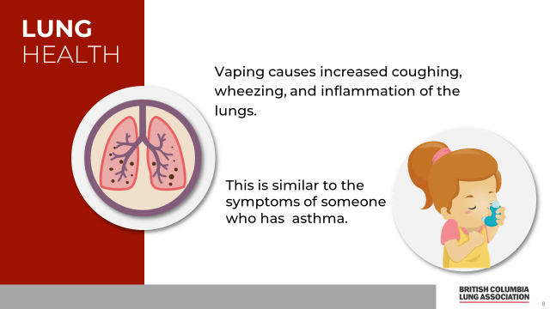 |  | - Read the statements to the students
9  Second-hand Vapour  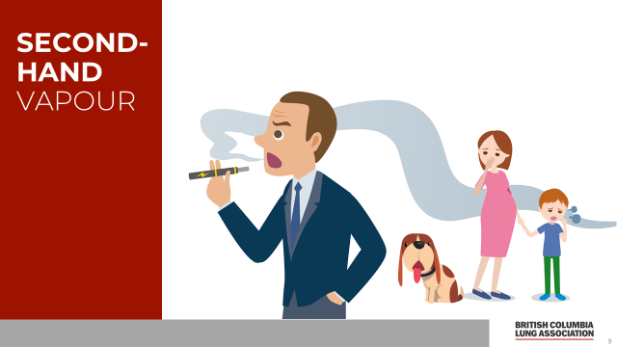 | - To understand that second-hand vapour can also be harmful to bystanders and pets | - Second-hand vapour is exhaled by the users and contains the same chemicals found in the vapour, which poses a risk to bystanders and pets.  - Can you give me some examples of places where people may breathe in second-hand vapour?  - E.g., school bathrooms, bus stops, on the bus, etc.
10  Fact or Myth? | - To assess students’ knowledge and engage them by playing “True or False”.  - To clarify the misconceptions associated with vaping products | Game: True or False  There are various ways to play this game.  How to Play – Ideas:  - “True” or “False” response cards  Prepare response cards. E.g.  Write “True” on one side of card in green and “False” in red on the other side. Distribute response cards to students. Have students raise their response card to each statement you pose. Ensure each raised card faces you so you can assess the number of correct responses and see how much students know about this topic. You could divide the class into groups to allow discussion and use fewer response cards.  - Have students stand in a line in the centre of the room. If the statement is “true”, student can step to the right. If the statement is “false”, student can step to the left. Please note: Some may feel “exposed” if they did not get the correct response because everyone can see everybody else’s response based on which side of the line they step. However, it might be fun and is a good way to get the students more engaged instead of sitting at their desks.
11  True or False  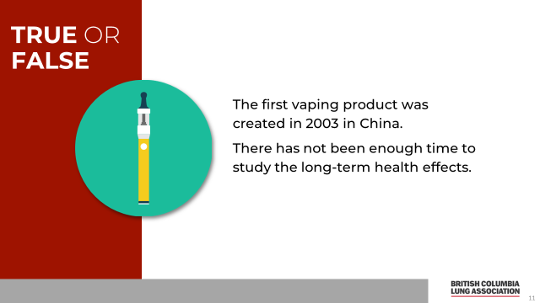 |  | - Read the statement to the students
12  True  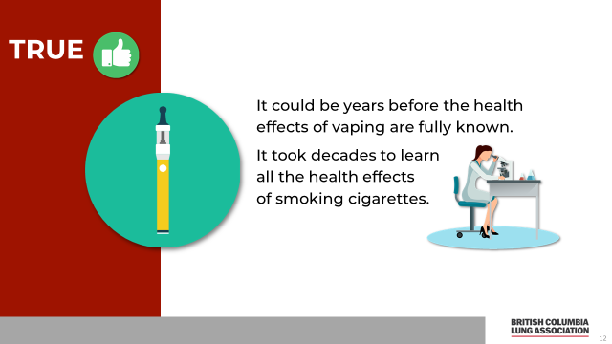 |  | True  - E-cigarettes were invented in 2003 by a pharmacist in China, who wanted to make a device less harmful than cigarettes to deliver nicotine.  - Only the short-term health effects, such as irritation to the lungs are known.  - It may take scientists 15-20 years to learn about all the health effects of vaping.
13  True or False  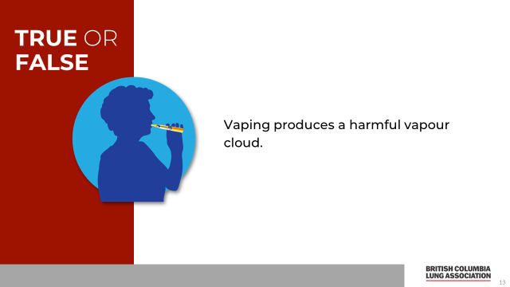 |  | - Read the statement to the students
14  True  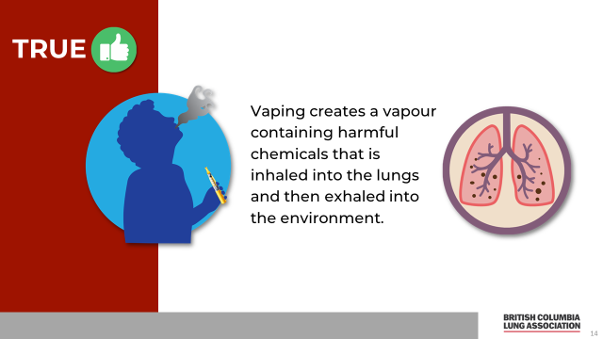 |  | True  - Remind students of the chemicals in the vaping products | - Chemicals in the vapour are outlined in slide 7.
15  True or False  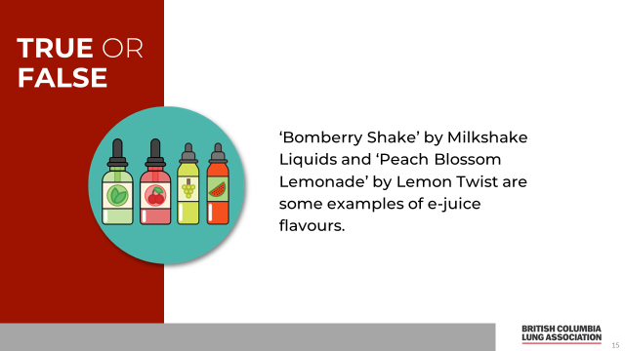 |  | - Read the statement to the students
16  True  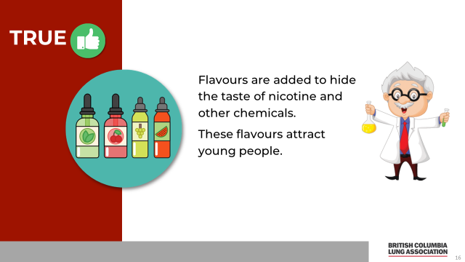 |  | True  - There are many flavours to attract youth. It is one of the main reasons for why youth try vaping.  - Flavours hide the taste of nicotine and chemicals  - Popular flavours include menthol, alcohol, candy and fruit. | - Note to the teacher: Can elaborate that the flavours are highly appealing to youth. It is one of the main reasons for trying vaping.
17  True or False  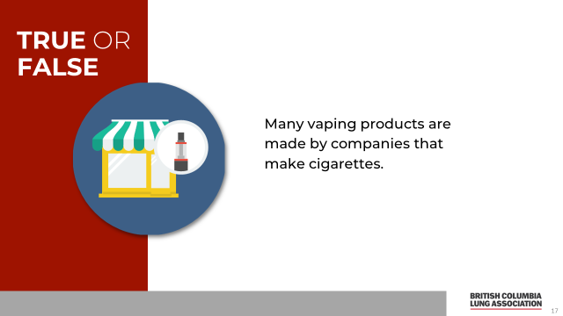 |  | - Read the statement to the students
18  True  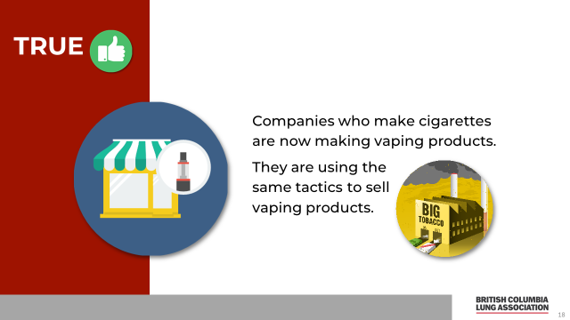 |  | True  - Over time, big tobacco companies have either taken over smaller vaping product companies or have made substantial investments e.g. Altria owns 35% of JUUL | - Vype and Blu are owned by Imperial Tobacco/British American Tobacco  - Vuse is owned by R. J. Reynolds
19  Play the Video  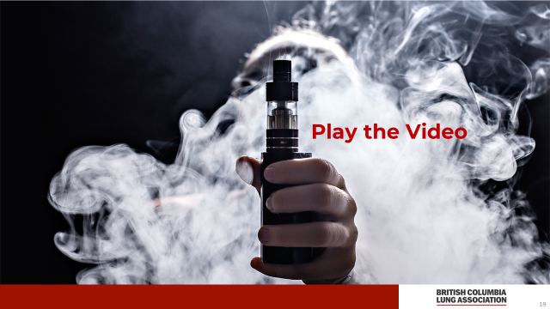 | - To initiate student discussion on the marketing tactics of the tobacco industry at that time and how similar it is with the current strategies used to promote vaping products. | - Click on words “Play the Video” on the PowerPoint  - Video clip is from 1949 from Camel cigarettes.  - This commercial is from a time when we knew smoking was bad for us yet the tobacco companies used marketing tactics like these (a doctor smoking) to sell their product and downplay the health effects of smoking.  - Let’s now look at some ads comparing cigarette and vaping product advertising
20  Advertising | - To demonstrate how vaping products are being marketed in the same way that tobacco was in the past (e.g. glamour and lifestyle advertising). | - Here are two American ads comparing past cigarette and current vaping product advertising.  - What messages and/or feelings is the company trying to create in the tobacco ad?  - What messages and/or feelings is the company trying to create in the vaping ad?  - Using lifestyle advertising to promote tobacco is illegal in Canada, but you can still see it online (and in some publications outside Canada) | - Discuss the advertisements as a group
21  Advertising  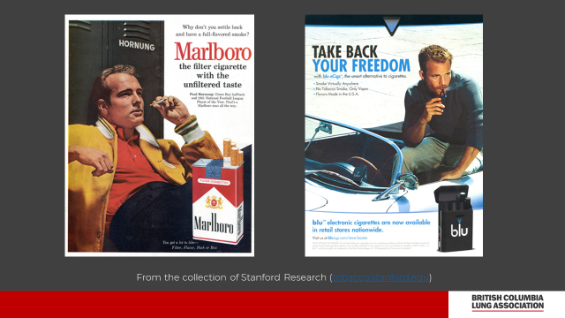 | - To demonstrate how vaping products are being marketed in the same way that tobacco was in the past (e.g. lifestyle advertising). | - Here are two more American ads comparing past cigarette and current vaping product advertising.  - What messages and/or feelings is the company trying to create in the tobacco ad?  - What messages and/or feelings is the company trying to create in the vaping ad?  - Using lifestyle advertising to promote vaping products is illegal in Canada, but you can still see it online (and in some publications outside Canada)
22  As Seen on Social Media  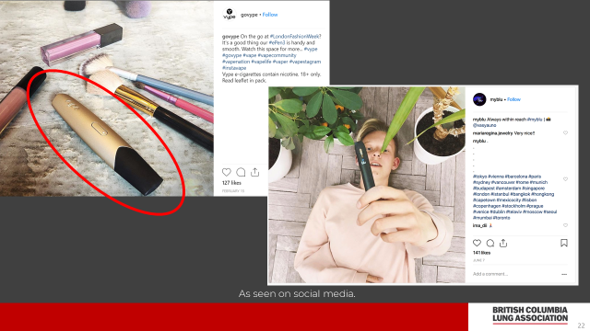 | - To show vaping product companies are using social-media platforms to advertise their products | - Here are some social media ads  - What is the message?  - Vaping product companies also use lifestyle advertising and influencers to promote their products.  - Multi-media channels are being used.
23 | - To highlight that most e-juice contains nicotine. | - These are e-juice bottles.  - Most e-juice contain nicotine.  - Even e-juice labels that say, “nicotine-free” have been found to contain nicotine.  - Children and adults have been poisoned by swallowing the e-juice or absorbing it through skin. | Story of interest:  - Langley elementary school students find a discarded vaping product and gets sent to hospital:  https://globalnews.ca/news/5422849/langley-elementary-vape-pen/
24  Nicotine Facts  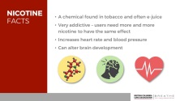 | - To explain what nicotine is and how it can have a negative impact on the body | - Read the statements to the students
25  Nicotine Facts  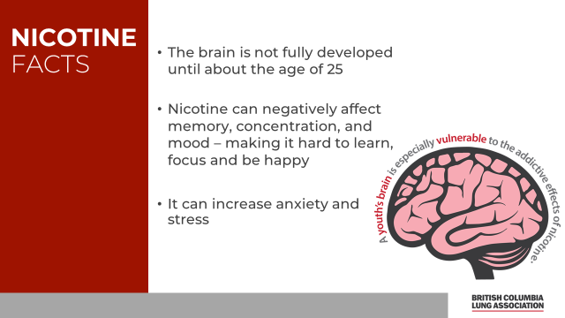 | - To describe how nicotine exposure affects the brain | - One of the primary concerns with youth vaping is the exposure to nicotine, and how it impacts brain development in youth.  - Nicotine causes the release of certain chemicals in the brain to create feelings of pleasure. However, once that wears off, the opposite occurs. E.g. low mood, agitation, tiredness and decreased focus – This is also known as nicotine withdrawal.
26  Costs  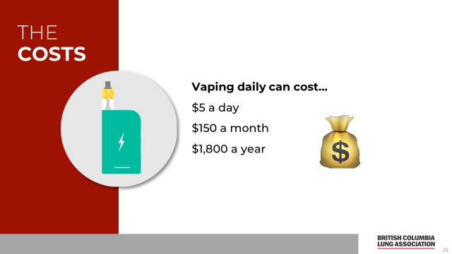 | - To understand the cost of vaping | - Cost will vary depending on the vaping product, how much is used, how often, etc. | - These costs were calculated based on using one JUUL pod a day and buying from a legal source/store.  - Buying through the black market can cost students more. (E.g., older siblings/friends/students may buy vaping products and sell them to younger students at a much higher price.)
27 | - To help students understand that there are better ways to spend their money | - Ask the students to provide examples of what they would buy with $1,800.  - What can you do with $1800?  - E.g. Trip to Hawaii, new computer, laptop, cell phone etc.
28 | - To know that there are laws that regulate the promotion and sales of vaping products. | - In PEI, how old do you have to be to buy vapes?  - 21 years old*  - *In 2020, the minimum age to purchase vaping and tobacco products will be raised to 21. A bill was passed in November 2019 to change this law but the law is yet to be proclaimed and made into an official law.  - This new bill will also restrict where vaping products can be sold and eventually ban certain flavours  - Video: Global News (3 mins)  - https://globalnews.ca/news/6196151/proposed-p-e-i-law-would-strictly-regulate-vaping-raise-age-limit/ | - It is illegal to sell vaping products to anyone under 21 in PEI*  - It is illegal for anyone to buy or give a vaping product to anyone under 21*
29  Remember this |  | - From this session, what are some key points you learned?  Summarize key points
30  Bingo |  | Game: BINGO (CLOUD!) Game  How to Play:  - Distribute bingo cards to students  - Read out questions to students.  - Ask students to mark an ‘x’ on the correct answer on the bingo card. When they complete a line (horizontal, vertical or diagonal), they should raise their hand and say ‘Cloud!’. | Optional idea:  Distribute bingo chips to students and use on the correct answer.
31 |  |  | - You may place the school logo on this slide.

